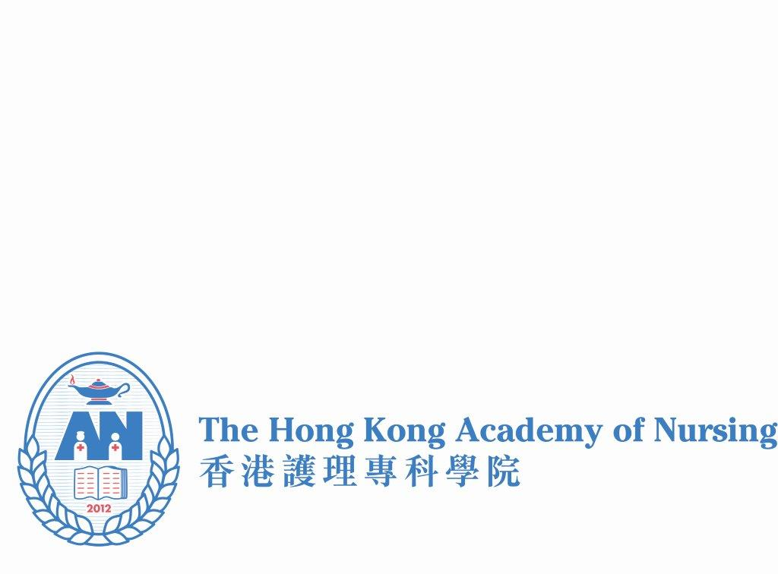

**Enrollment Form**

Seminar: **Medical Social Collaboration – HKEC Experience**

Speaker: Ms. WONG Man-ying Daisy  
 HKEC Community Service Honorary Advisor

Date: 15 December 2018, Saturday

Time: 9am – 11am (2 hours)

Venue: Lecture Theatre, at Lower Ground 2, School of Nursing, Princess Margaret Hospital, 232 Lai King Hill Road, Lai Chi Kok, Kowloon

Course Fee: HK$300 per person

CNE Point: 2 points

Enrollment Deadline: 30 November 2018

|  |  |  |
| --- | --- | --- |
| Please return the completed enrollment form **with payment proof** to HKAN Office by email: [eo@hkan.hk](mailto:eo@hkan.hk) or by Fax: 2370 0216 | | |
| **Full Name (in block letters) :** | |  |
| **HKAN Membership No. :** | |  |
| **Academy College :** | |  |
| **Current Work** | **Position :** |  |
| **Specialty :** |  |
| **Organization :** |  |
| **Mobile No. :** | |  |
| **Email address :** | |  |
|  | |  |

Payment Method: Please settle payment via Bank-in / ATM:

Hang Seng Bank

227-452992-001

**The Hong Kong Academy of Nursing Limited**

***Enquiry to:*** [***eo@hkan.hk***](mailto:info-enquiry@hkan.hk) ***Telephone: (852) 2370 0335 Fax: (852) 2370 0216***